Lesson 02 Demo 03

Creating and Assigning Tags to Resources via Azure Portal

Objective: To create and assign tags to resources via Azure portal

Tools required: Azure account with Contributor access

Prerequisites: None

Steps to be followed:
- Create Azure tags

Step 1: Create Azure tags

- Sign in to the Azure portal



- Navigate to your resource or Resource groups at the Azure Portal

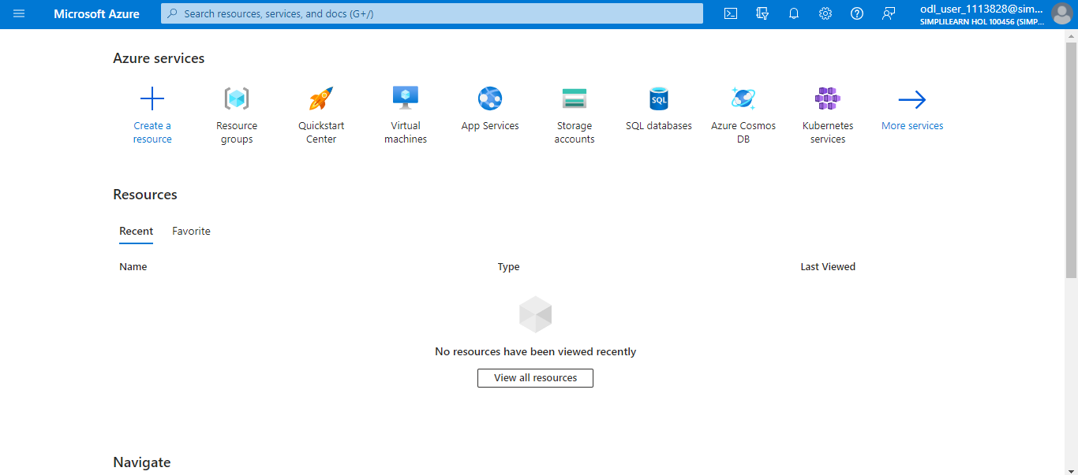

- To view the tags for an existing resource or a resource group, search for existing tags in the Overview (If you have not previously applied tags, the list will be empty.)

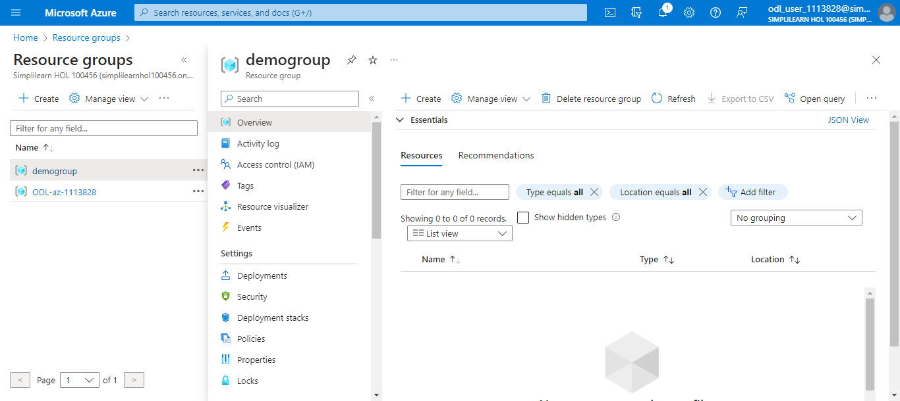

1.4 Click on Essentials

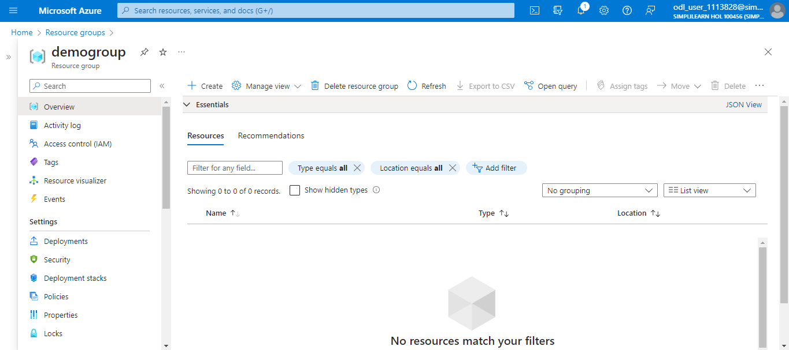

1.5 To add a tag, select Add tags
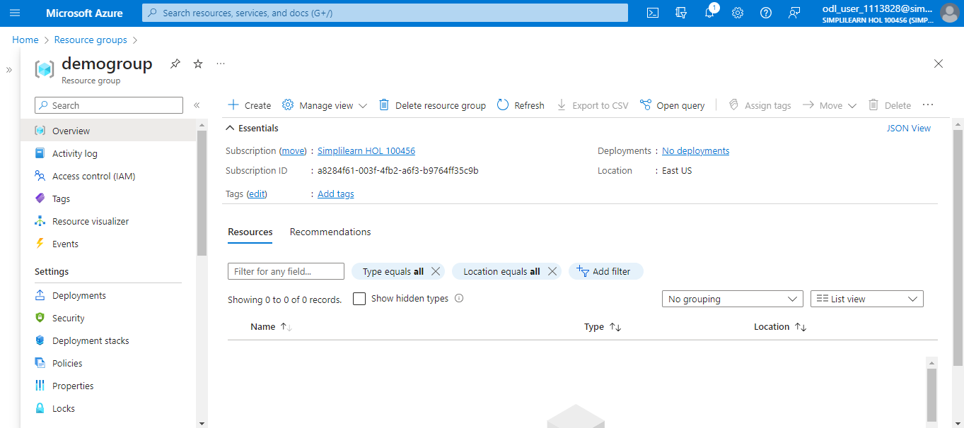

- Provide a Name and Value to tags
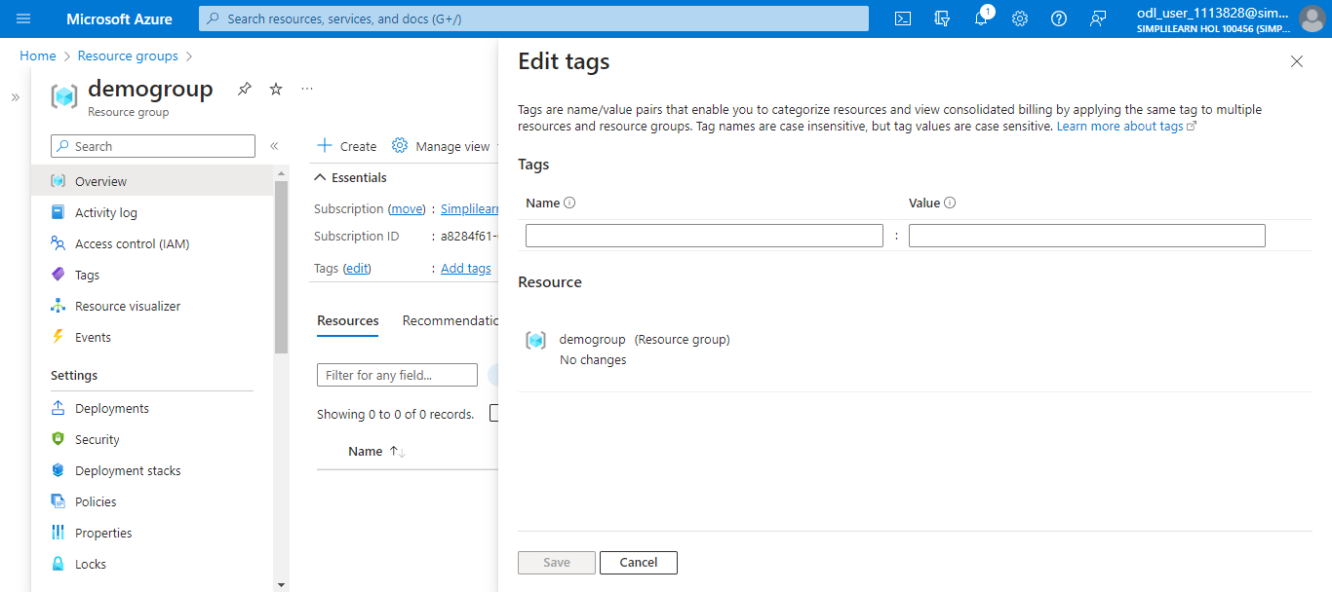

- Continue adding tags as needed and then select Save
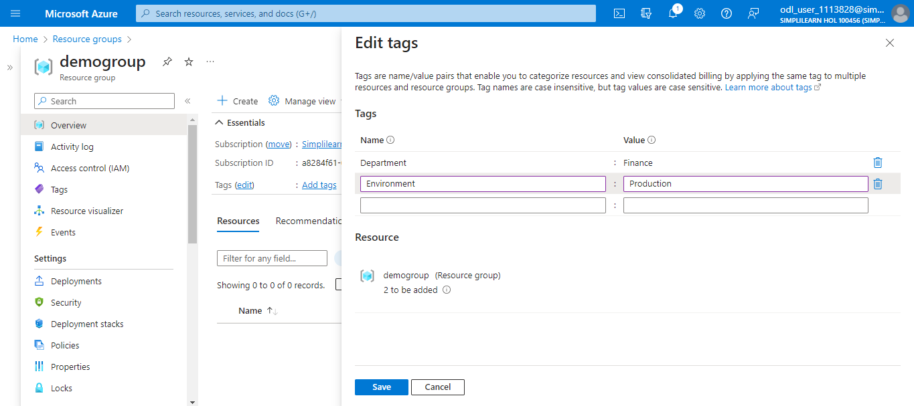

- Click on Overview to display the tags
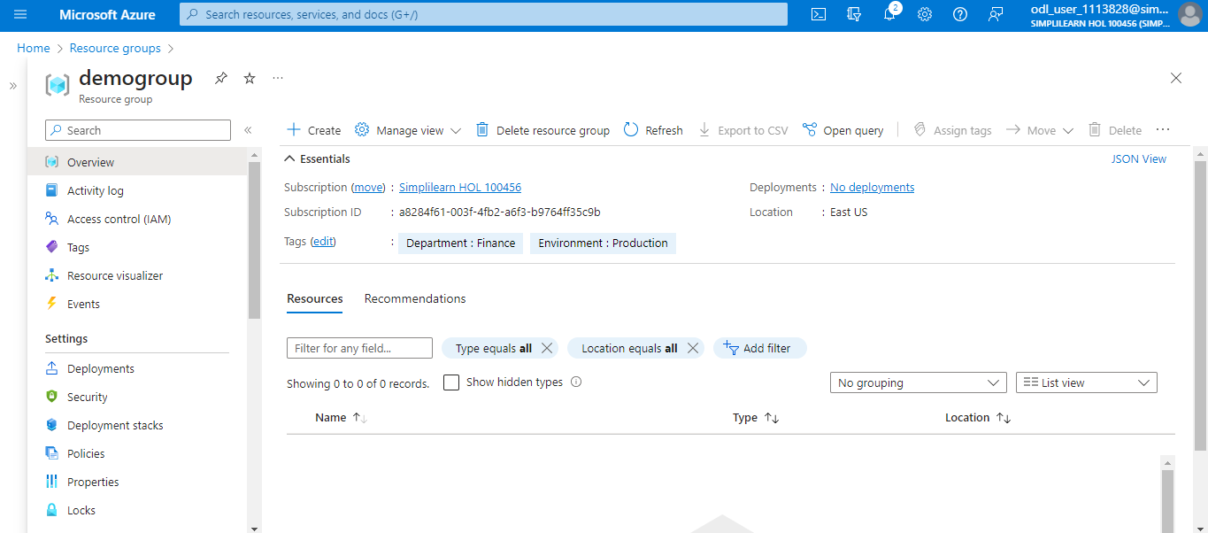

You can now use an Azure account with Contributor access to create and assign tags to resources via the Azure portal.

